email no.mtprmu_kolkata@yahoo.com
METRO RAILWAYMEN’S UNION
[AFFILIATED WITH ALL INDIA RAILWAYMEN’S FEDERATION]
RECONGNISED BY METRO RAILWAY ADMINISTRATION
33/1,J.L.NEHRU ROAD,
METRO RAIL BHAWAN,
KOLKATA-700071
[REGD.NO11951]

No. MRMU/Covid-19/Staff Safety Date:- 29.04.2021

To
The General Manager,
Metro Railway, Kolkata.

Dear Sir,
Sub:- Review of Commuter service in the waked rapid spread of Covid virus.

Kindly recall union’s letter of even no. dtd.19.04.2021 .

You are definitely aware that a large number staff associated with train operation and maintenance shed have been infected with Covid-19 virus. Quick and efficient vaccination ,still in dream, to achieving hard immunity against the virus. So, the number of infected have been increasing at an alarming rate as a result some offices or sections in the field are likely to be collapsed for lack of manpower.

On the other hand, there appear a demand supply mismatch after vaccine eligible population expanded w.e.f 1st.May. There is already impact on the number of passengers of Metro services. At present there are around 1.6 lakh passenger ferried by 238 by rakes with time frame from 7.20 A.M to 9.10P.M. the number of passengers has been slashed from 2.85 laks a few days back.

In the above context, taking all fectors viz. Number of passerngers , number of Covid effected staff etc. Continuation of both time of span and number of trains is required to be scaled down as a prudent step.

Union urges to consider timings of service from 8A.M to 7 P.M. till the situation improves. This may help to follow staggered roster as per Covid -19 protocol.

An early action is solicited.
Thanking you,

Yours faithfully,
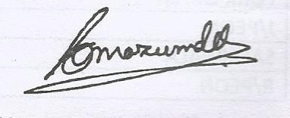
(Sisir Ch. Mazumder)
General Secretary/ MRMU

